**Assignment 2**

Question 1

Used a variable named rows to take input from the user and used nested for loop to print the given pattern.

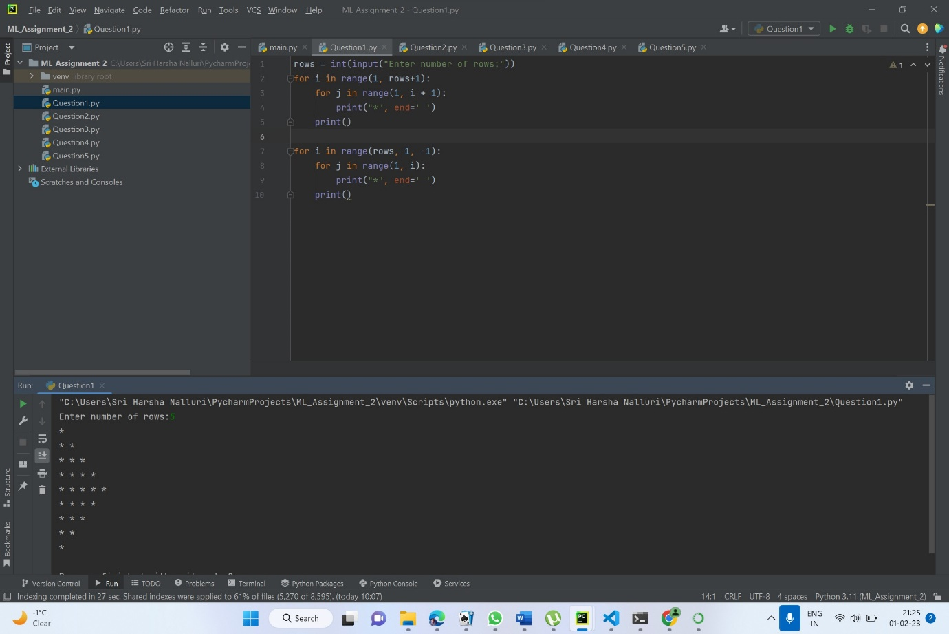

Question2

Taken a list using a variable odList and while loop to print the odd indexed values.

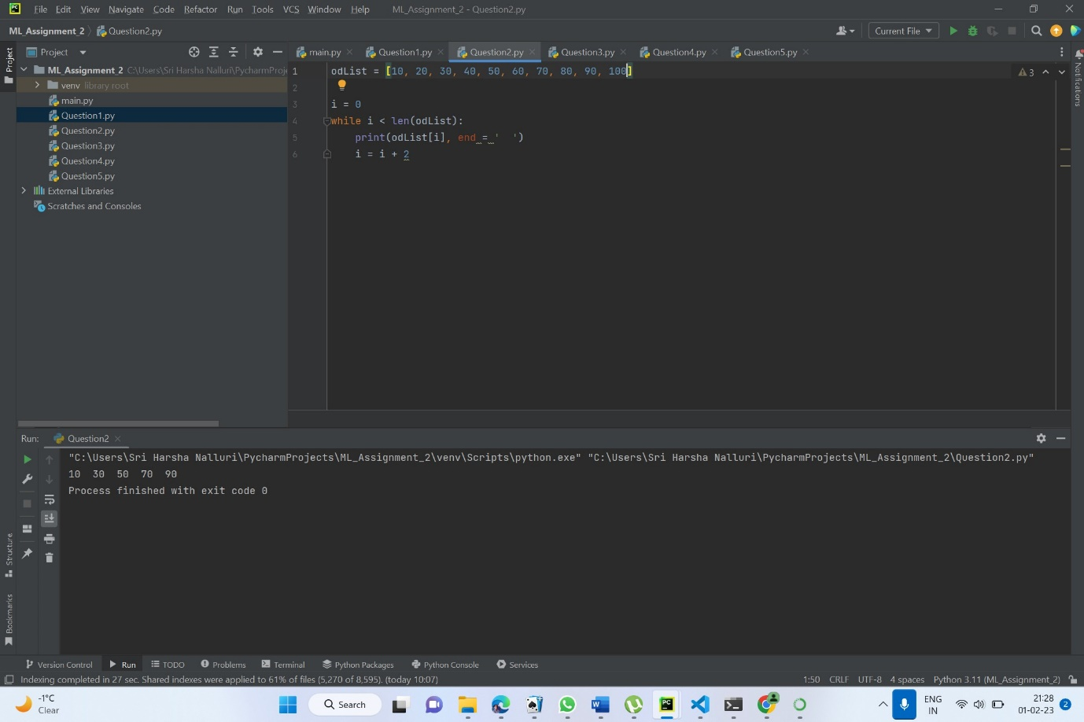

Question3

Taken a list named lst and created another list named list to store the data type of the element of lst. Used type() function to get the data type and printed both lists.

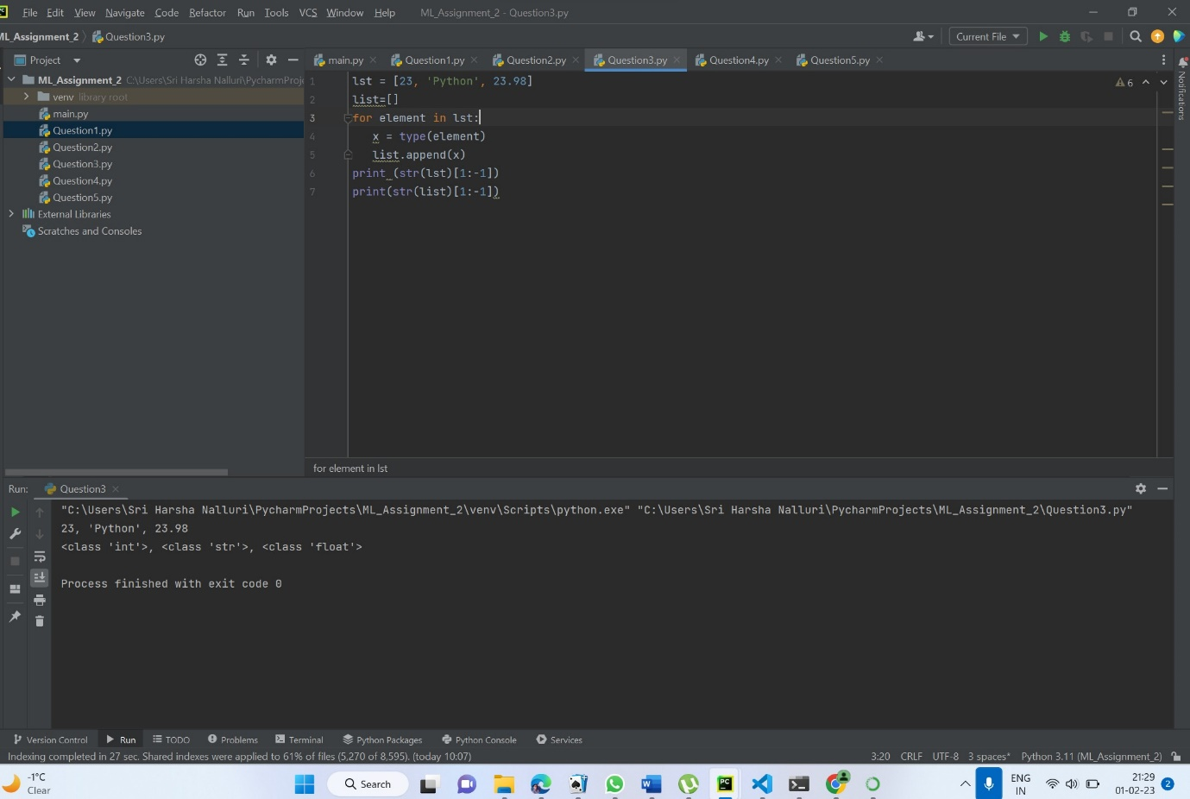

Question 4

Created a function unique to get the unique numbers from the list.

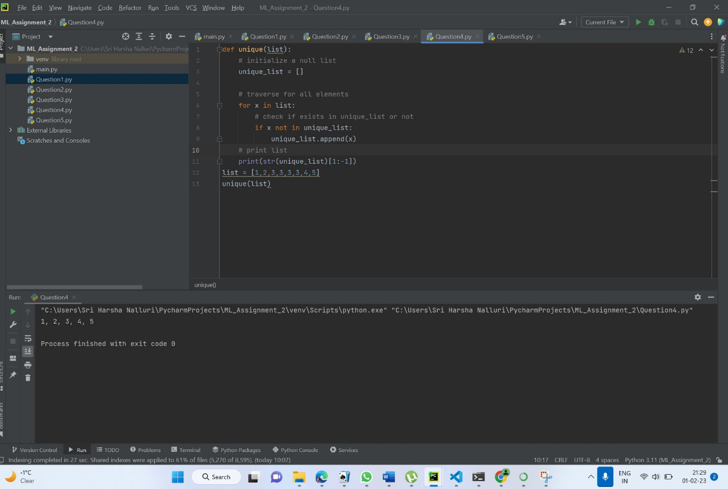

Question5

Used for loop and isupper() and islower() functions to know the number of lowercase letters and uppercase letters from the given string.

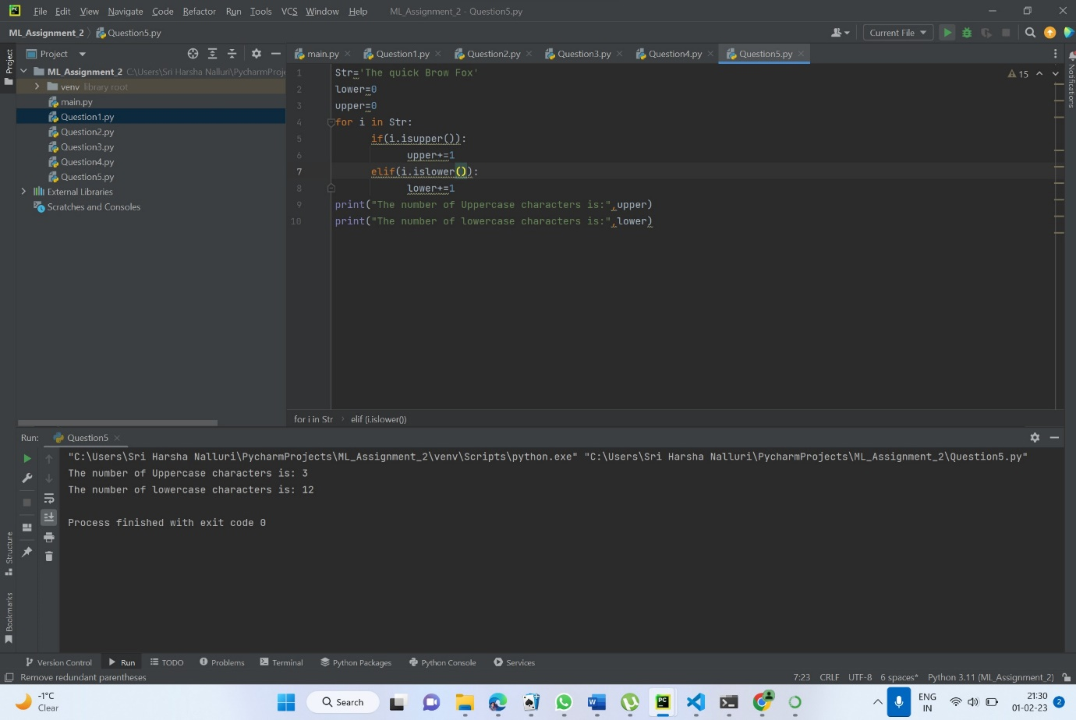

Video link:

https://drive.google.com/file/d/1StP6A-o1Y4SBy-3aAcT9nzF4Da9kwPLM/view?usp=sharing